Addition Face Off (Addition War)
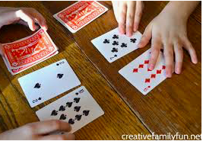

LEVELS
Grades 1 - 3

SKILLS
- addition facts 1 to 10
- 1 to 18 combinations

PLAYERS
- 2

EQUIPMENT
- Grades 1 - 2: playing cards Ace (= 1) through 5 (making sums to 10)
- Grades 2 - 3: playing cards Ace (= 1) through 9 (making sums to 18)

GETTING STARTED
Players divide the cards in the deck evenly between themselves. Each player turns over two cards and adds them together. The highest sum gets all of the cards.
In the event of a tie (if each player has the same sum), war is declared. Each player deals out three more cards face down. Then each player turns over two more cards and adds the sum of the numbers on those cards to the original sum. The highest sum wins all of the cards.
Play continues until one player has collected all of the cards.

